Sprint Retrospective – sellers crum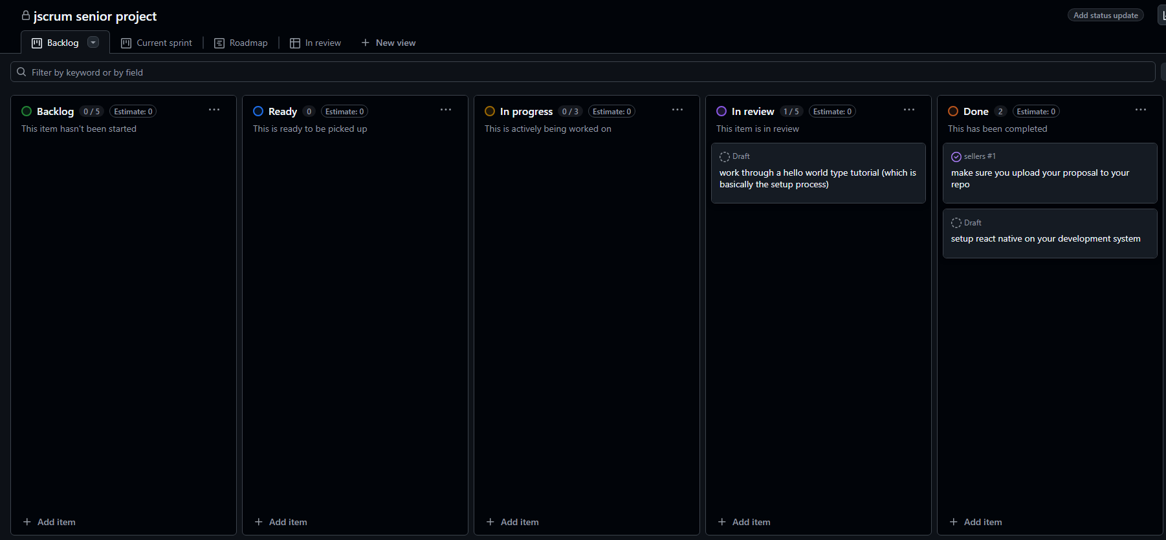

Project Title
Mybiketraffic app

Sprint Number
Sprint 3

Sprint Duration
Feb 18 – March 4

Date of Retrospective
March 5

Sprint Goals
Create the skeleton of the overall app using NPM install and create placeholder screens

Accomplishments
Both goals were accomplished

Challenges
Difficulty in correct syntax of commands

Next Steps
Create web mv version of app

